Az idő csodás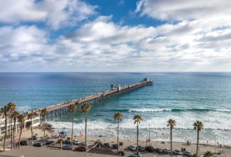

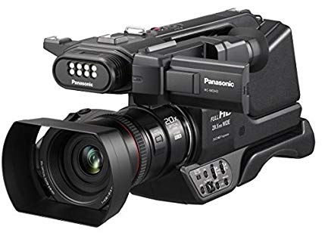

A **camera** is an [optical](https://en.wikipedia.org/wiki/Optics) instrument to capture [still images](https://en.wikipedia.org/wiki/Still_image) or to record [moving images](https://en.wikipedia.org/wiki/Moving_image), which are stored in a physical medium such as in a [digital system](https://en.wikipedia.org/wiki/Digital_storage) or on [photographic film](https://en.wikipedia.org/wiki/Photographic_film). A camera consists of a [lens](https://en.wikipedia.org/wiki/Camera_lens) which focuses light from the scene, and a [camera body](https://en.wikipedia.org/wiki/Camera_body) which holds the image capture mechanism.

Still images stored in digital form are called "[image files](https://en.wikipedia.org/wiki/Image_file)," while moving images similarly stored are called "[video](https://en.wikipedia.org/wiki/Video) files." In the deprecated paradigm of [photographic film](https://en.wikipedia.org/wiki/Photographic_film) for image storage, still images are simply called "photographs," and moving images are called "[films](https://en.wikipedia.org/wiki/Films)." The still image camera is the main instrument in the art of [photography](https://en.wikipedia.org/wiki/Photography) and captured images may be reproduced later as a part of the process of photography, [digital imaging](https://en.wikipedia.org/wiki/Digital_imaging), [photographic printing](https://en.wikipedia.org/wiki/Photographic_printing). The similar artistic fields in the moving image camera domain are [film](https://en.wikipedia.org/wiki/Film), [videography](https://en.wikipedia.org/wiki/Videography" \o "Videography), and [cinematography](https://en.wikipedia.org/wiki/Cinematography).

The word *camera* comes from [*camera obscura*](https://en.wikipedia.org/wiki/Camera_obscura), which means "dark chamber" and is the Latin name of the original device for projecting an image of external reality onto a flat surface. The modern photographic camera evolved from the camera obscura. The functioning of the camera is very similar to the functioning of the human eye. The first permanent photograph was made in 1825 by [Joseph Nicéphore Niépce](https://en.wikipedia.org/wiki/Joseph_Nic%C3%A9phore_Ni%C3%A9pce).